Linkedin

[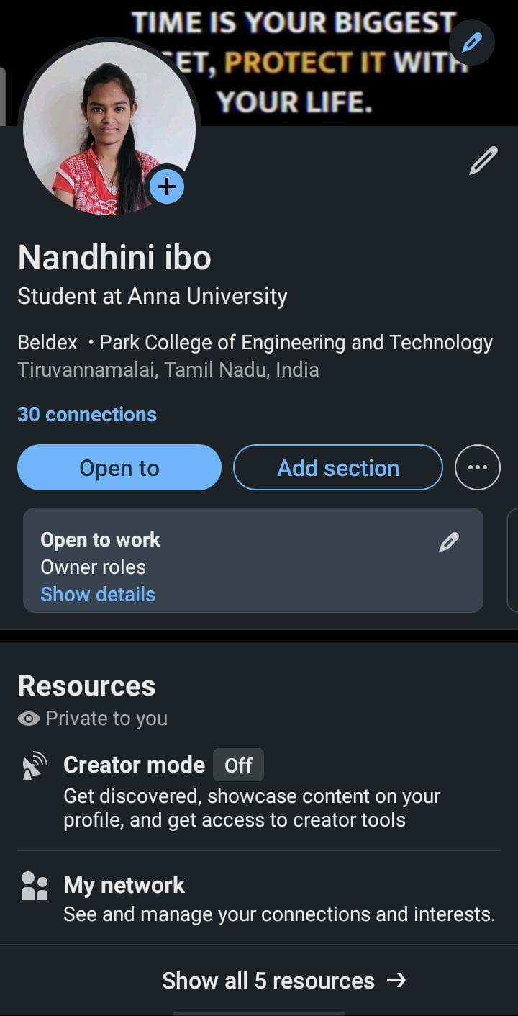](https://www.linkedin.com/in/nandhini-ibo)https://www.linkedin.com/in/nandhini-ibo

Facebook Ad

<https://www.facebook.com/profile.php?id=61550069705330&mibextid=ZbWKwL>

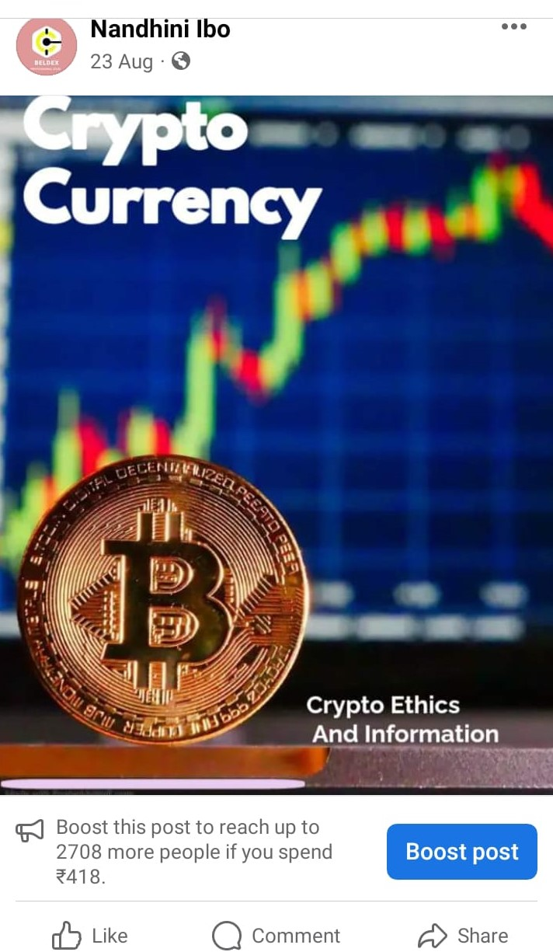

Email newsletter

[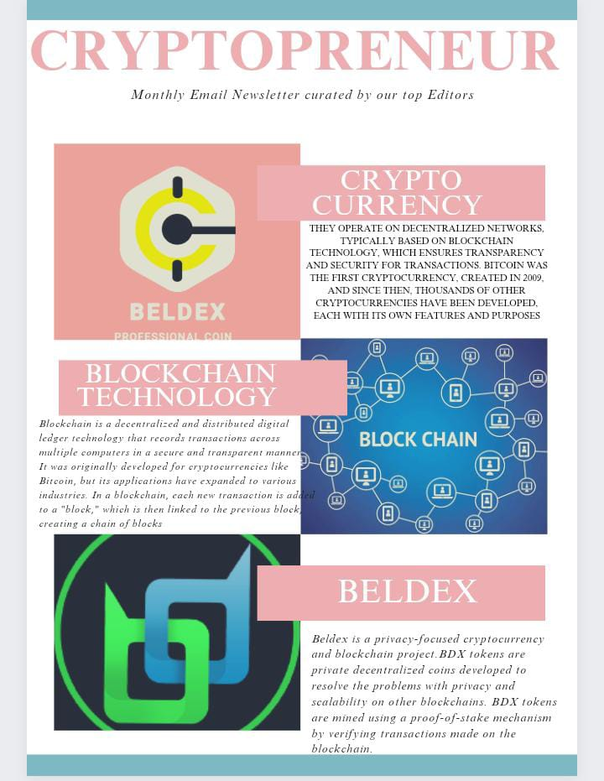](https://www.canva.com/design/DAFw74ladV4/H8yHKUbiVX471cPS_5lljQ/edit?utm_content=DAFw74ladV4&utm_campaign=designshare&utm_medium=link2&utm_source=sharebutton)https://www.canva.com/design/DAFw74ladV4/H8yHKUbiVX471cPS_5lljQ/edit?utm_content=DAFw74ladV4&utm_campaign=designshare&utm_medium=link2&utm_source=sharebutton

Infography

[](https://www.canva.com/design/DAFw7w77Ljo/-gj3K0KU-R-PeaB98KLuUA/edit?utm_content=DAFw7w77Ljo&utm_campaign=designshare&utm_medium=link2&utm_source=sharebutton)https://www.canva.com/design/DAFw7w77Ljo/-gj3K0KU-R-PeaB98KLuUA/edit?utm_content=DAFw7w77Ljo&utm_campaign=designshare&utm_medium=link2&utm_source=sharebutton

[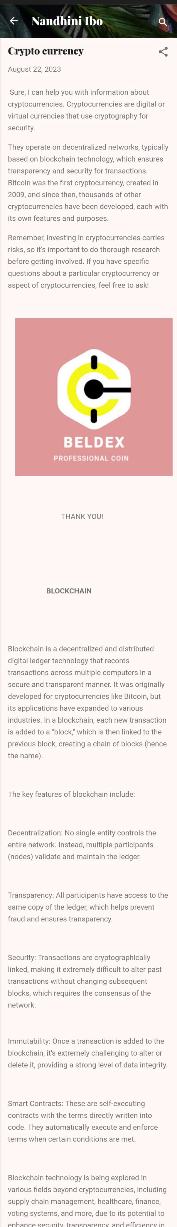](https://nandhiniibo.blogspot.com/)https://nandhiniibo.blogspot.com/

Blog

Google Analytics

[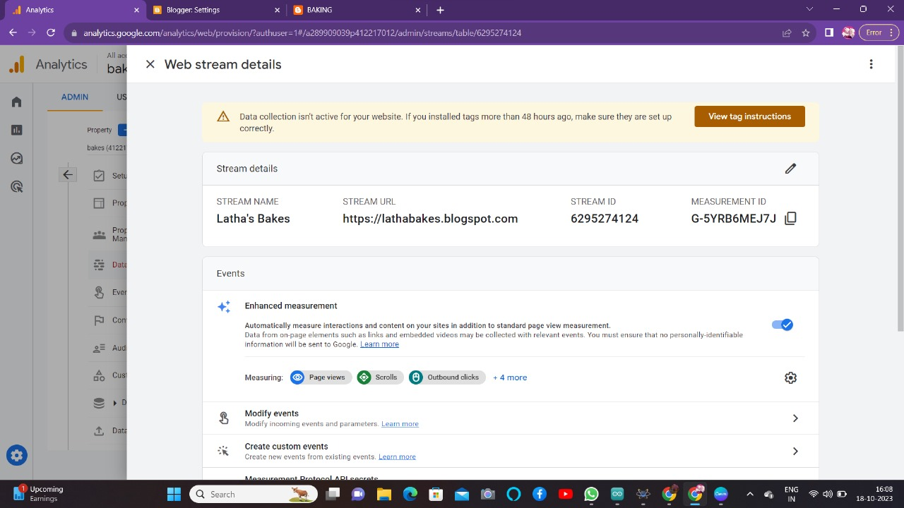](http://G-VNE9CPXPZY/)http://G-VNE9CPXPZY/